Introduction to the Drama Triangle,
- and the Outcome Triangle

In 1968, Stephen Karpman published an article titled Fairy Tales and Script Drama Analysis, in Transactional Analysis Bulletin. It was a hugely impactful description of how drama is played out in real life, as well as in Fairy Tales.
In short, the idea is that there are three dysfunctional roles that people play with each other, switching roles at times. The faster the switching goes on, the more drama there is between them all. There is the Rescuer, the Persecutor, and the Victim.
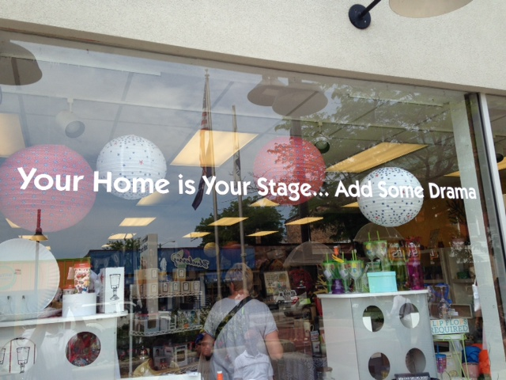
A healthier, more adult way to be is to be the Mindful Observing Witness, the Coach, or the Challenger.
The section that follows was found on the Internet somewhere. I don’t know whom to credit for it, but it isn’t me. I’ve made some formatting changing, and tweaked it a little, but it basically comes from someone else. I’ve put it in a different font in order to differentiate it from the rest of my work.
You will also see that I’ve added some more material at the end about how this drama triangle fits in a variety of situations. I’m responsible for that material. I’m also referencing ideas derived from David Emerald’s book The Power of TED: The empowerment dynamic.
+ + + + + + + + + + + +

Karpman Drama Triangle

The Karpman Drama (or Trauma) Triangle is a model of how individuals interact with the overall result being to create painful emotional states – or, as we commonly refer to it, drama. This is mostly an unconscious process, so there is collusion at some level around a shared intention. The design of the model requires two individuals (or entities) but three roles. It is suggested that all drama originates from one of these three roles, and the switching that takes place from role-to-role is where the drama really comes in, and accelerates as roles change faster and faster.

There are three roles, or three faces in every drama: Persecutor, Rescuer and Victim.

The rules of the game are as follows:

- If one plays a role, then you will eventually play all three roles.
- Each person has a preferred and familiar role.
- The more switches in roles, the more excitement and drama is created.
- The underlying motive of the game involves “getting recognition or energy”.
- If positive energy or recognition is not available, human beings will accept negative energy or recognition. (It is better to be wanted for murder than not wanted at all.) However, people will not live without recognition.
- One negative outcome of this interaction is that the victim is left without positive recognition, power, esteem, and still lacks the necessary skills and knowledge to succeed. There are more negative outcomes than this, of course, for each player. The Rescuer suffers from being an enabler, and the Persecutor from being mean.
- The Drama Triangle is predictable and therefore individuals play roles in an attempt to avoid the risk of uncertainty. Roles manage the anxiety of uncertainty in predictable ways, even though they are dysfunctional.

A closer examination of the roles:

RESCUER:

- Perceives self as having all the answers. Wants to relate to the world and others as a minor deity.
- Can only feel good and needed by having someone else who requires help (the helpee, or victim).
- Self-esteem is based on helping out others who are in trouble.
- Feels superior to victim (and the victim feels inferior).
- Believes victim cannot succeed without help.
- If victim is not in trouble, the Rescuer may have a stance of aloofness or coldness.
- Is significantly more invested (emotionally and behaviorally) in the transaction with the victim than is the victim himself or herself.
- The Rescuer volunteers helpful suggestions, solutions, answers, even though they have not been requested.
- Rescuers experiences difficulty in stating feelings, particularly anger.
- Has to ignore or rebuff compliments or positive feedback; to accept recognition means the Rescuer has needs and is as human as the victim.
- Rescuer receives as much recognition from rescuing as does the victim from being rescued.
- Basic stance: I’m acceptable and you’re not. (I’m Ok, and You’re Not Ok)

VICTIM

- Perceives that his or her own needs and feelings are insignificant.
- Feels like a victim and perceives one’s self as a victim, but may not be.
- The particular task or job before them, or other’s needs and feelings are more important than the Victim’s.
- Only feels cared about when in trouble; otherwise he or she believes that no one will care or recognize them.
- Positive interactions with others can only occur if the Victim remains in a one-down, loser, hurting position.
- The Victim either does not provide an agenda, or has a completely unrealistic agenda, thus setting the Rescuer up to provide the agenda.
- Desires that others engage in mind-reading, and when they do the Victim will often deflect or comply.
- Refuses compliments because to accept positive feedback will result in feeling better and gaining self-esteem.
- Perceives outside forces to be controlling one’s life. “I am only a helpless pawn in the overall scheme of the universe,” or “there is little I can do to feel better about myself without it.”
- Furnishes less than 50% of the energy in the transaction.
- Plays “Yes, but”, “Manana”, “I’m too weak, small, powerless, helpless, stupid, old, inept, etc.”
- Basic Stance: I’m unacceptable and you are okay (I’m Not OK, and You are OK)

PERSECUTOR

- Has no real power – all power is, in reality, assigned by the Victim.
- Primary feeling is outrage.
- Behavior is rage, sarcasm, criticism, shaming, blaming.
- Frequently attempting to control and manipulate the victim.
- If unable to motivate victim, then wins the game by making the victim experience emotional pain.
- Can either place more than 50% of the energy into the transaction, or adopt a passive-aggressive, defiant stance. In either case, the position is one of punishing and control.
- Emphasis in on a win/lose strategy
- Basic stance: I’m acceptable and you are not. (I’m OK and You’re Not OK)

The Empowerment Dynamic

David Emerald has written a wonderfully readable and useful little book about TED: The Empowerment Dynamic. His “antitidote” to the drama triangle is to move from being the victim, to being the Creator. To move from the persecutor to being a Challenger. From being the rescuer to being a Coach. I cannot recommend this book enough. I’ve given scores away to clients in my office.

My Version, when it is all integrated.

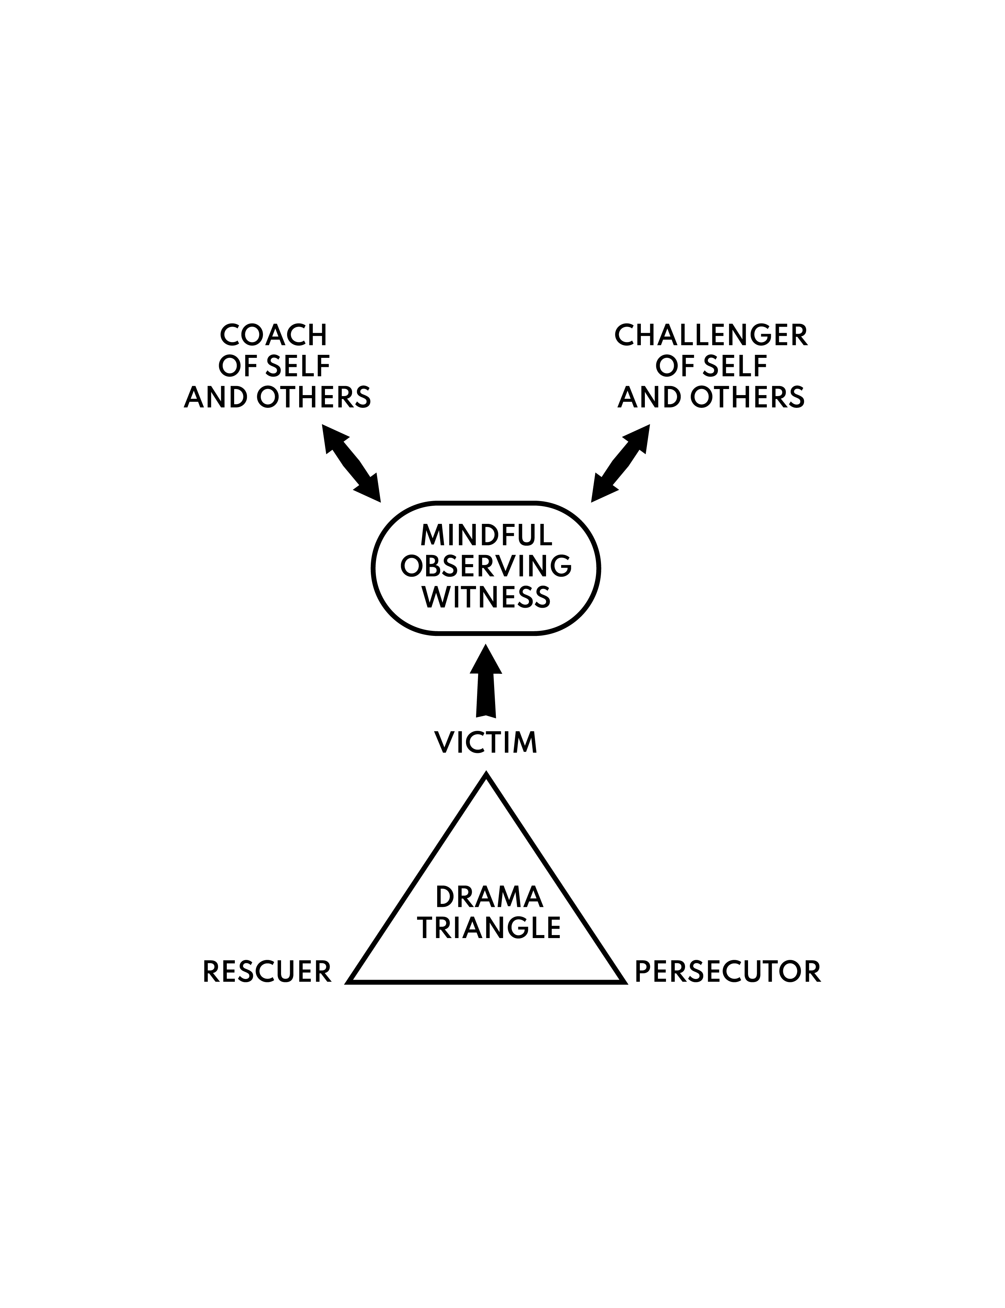

MINDFUL OBSERVING WITNESS:

- Objectively steps back and observes the drama triangle at play.
- Is a non-anxious presence.
- Due to the lack of fear from a disengaged mindfulness, more creativity is brought to the situation.
- Clearly identifies his or her needs and states them.
- Perceives the Victim not as a victim, but as the Helpee
- Perceives and expects himself or herself to be in command of one’s own self, and thus in charge of the transaction.
- Furnishes more than 50% of the energy.
- Is able to identify and express feelings at any point in the transaction.
- Readily expresses those feelings in appropriate ways.
- Requests and provides appropriate compliments and recognitions.
- Basic stance: I’m acceptable and so are you (I’m OK, and You’re OK).

COACH:

- Furnishes less than 50% of the energy in the transaction. Does not over-invest in the relationship.
- When the Coach decides to initiate transaction or offer help, goal is to quickly transfer responsibility to the Helpee, thus empowering the Victim to take responsible for one’s own self.
- Negotiates with the Helpee for involvement, jointly determining the extent of the Coach’s contribution.
- Knows when to say “yes” or “no”.
- Able to identify and express feelings at any point in the transaction.
- Accepts, provides and requests compliments and recognitions.
- Understands that Helpee is in charge of the transaction.
- Goal is for a win/win outcome.
- Basic stance: I’m acceptable and so are you (I’m OK and You’re OK)

CHALLENGER:

- Furnishes less than 50% of the energy.
- May furnish the initial piece of the energy, but quickly transfers the responsibility to the Helpee.
- States clearly when problems or trouble lies ahead
- Allows natural consequences to occur.
- Is focused on supporting the Helpee’s efforts to better his or her life.
- Basic stance: I’m acceptable and so are you (I’m OK, and You’re OK).

+ + + + + + + + + + + +

From Wikipedia on “Karpman Triangle”

Origin[edit]
The Drama Triangle is a social model that was conceived by Stephen Karpman, M.D., a student studying under Eric Berne, M.D., the father of transactional analysis. Berne encouraged Karpman to publish what Berne referred to as "Karpman's triangle". Karpman's article was published in 1968. Karpman received the Eric Berne Memorial Scientific Award in 1972 for this work.
Through popular usage and the work of Karpman and others, Karpman's triangle has been adapted for use in structural analysis (defining the conflict roles of persecutor, victim, and rescuer) and transactional analysis (diagramming how participants switch roles in conflict).^{[3]}

Theory[edit]
Karpman used triangles to map conflicted or drama-intense relationship transactions.^{[2]} The Karpman Drama Triangle models the connection between personal responsibility and power in conflicts, and the destructive and shifting roles people play.^{[4]} He defined three roles in the conflict; Persecutor, Rescuer (the one up positions) and Victim (one down position). Karpman placed these three roles on an inverted triangle and referred to them as being the three aspects, or faces of drama. Karpman, who had interests in acting and was a member of the Screen Actors Guild, chose the term "drama triangle" rather than the term "conflict triangle" as the Victim in his model is not intended to represent an actual victim, but rather someone feeling or acting like a victim.^{[2]}
- The Victim: The Victim's stance is "Poor me!" The Victim feels victimized, oppressed, helpless, hopeless, powerless, ashamed, and seems unable to make decisions, solve problems, take pleasure in life, or achieve insight. The Victim, if not being persecuted, will seek out a Persecutor and also a Rescuer who will save the day but also perpetuate the Victim's negative feelings.
- The Rescuer:
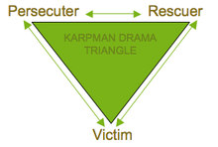
Karpman drama triangle
The rescuer's line is "Let me help you." A classic enabler, the Rescuer feels guilty if he/she doesn't go to the rescue. Yet his/her rescuing has negative effects: It keeps the Victim dependent and gives the Victim permission to fail. The rewards derived from this rescue role are that the focus is taken off of the rescuer. When he/she focuses their energy on someone else, it enables them to ignore their own anxiety and issues. This rescue role is also very pivotal because their actual primary interest is really an avoidance of their own problems disguised as concern for the victim’s needs.
- The Persecutor: The Persecutor insists, "It's all your fault." The Persecutor is controlling, blaming, critical, oppressive, angry, authoritative, rigid, and superior.
Initially, a drama triangle arises when a person takes on the role of a victim or persecutor. This person then feels the need to enlist other players into the conflict. These enlisted players take on roles of their own that are not static, and therefore various scenarios can occur. For example, the victim might turn on the rescuer, the rescuer then switches to persecuting — or as often happens, a rescuer is encouraged to enter the situation.^{[5]}
The motivations for each participant and the reason the situation endures is that each gets their unspoken (and frequently unconscious) psychological wishes/needs met in a manner they feel justified, without having to acknowledge the broader dysfunction or harm done in the situation as a whole. As such, each participant is acting upon their own selfish needs, rather than acting in a genuinely responsible or altruistic manner.^{[citation needed]} Thus any character from all of three in this triangle might "ordinarily come on like a plaintive victim; it is now clear that the one can switch into the role of Persecutor providing it is 'accidental' and the one apologizes for it". Real persecutor will never accept an apology or will not do anything to set up a normal and direct communication again. That one usually forbids contact or makes you feel unwelcomed while communicating indirectly with you. There is a difference when a victim has lost capabilities and when they are denied. It is important for a rescuer and persecutor to know that emotional capability is nothing less important than physical one. Bullying can leave traces that can't be retrieved, it can be mind-destructive to the point when an obstructive critic gives constant flashbacks that can't ever be forgotten and dismissed. This sabotages a victim even after an apology and slows the one in any life action in future. ^{[5]}
The motivations of the rescuer are the least obvious. In the terms of the drama triangle, the rescuer is someone who has a mixed or covert motive and is actually benefiting egoically in some way from being "the one who rescues". The rescuer has a surface motive of resolving the problem and appears to make great efforts to solve it, but also has a hidden motive to not succeed, or to succeed in a way that they benefit. For example, they may get a self-esteem boost or receive respected rescue status, or derive enjoyment by having someone depend on them and trust them – and act in a way that ostensibly seems to be trying to help, but at a deeper level plays upon the victim in order to continue getting a payoff.^{[citation needed]}.
In some cases, the relationship between the victim and the rescuer can be one of codependency. The rescuer keeps the victim dependent on them by encouraging their victimhood. The victim gets their needs met by having the rescuer take care of them even when the one doesn't want it. We must be careful here because we can victimize a victim if we indulge with initiating persecutor. If a victim asked nothing directly from a rescuer, it is an absurd to guess what somebody secretly wants. Some triangles are less complicated – some more and criteria are, usually, if something is held unresolved for many years it is mostly a police case. If a persecutor denies any responsibility from the root beginning of one's contact with a victim in life and still keep his/hers activity around a victim, then the victim must be saved from any influence of that persecutor.
In general, participants tend to have a primary or habitual role (victim, rescuer, persecutor) when they enter into drama triangles. Participants first learn their habitual role in their family of origin. Even though participants each have a role with which they most identify, once on the triangle, participants rotate through all the positions, going completely around the triangle.^{[6]}
Each triangle has a payoff for those playing it. The antithesis of a drama triangle lies in discovering how to deprive the actors of their payoff. If somebody requires nothing, that one is not to blame for anything. ^{[2]}

Here are some observations I’ve made over the years about how Drama Triangle work. This is an evolving list. Feel free to add your own observations.

- Whenever there is drama in the home or the workplace, the Drama Triangle can be used to unpack the interaction. We get into drama all the time, and the location isn’t that important. Having two or more players is all it takes.
- We learn to play these roles and the Drama Triangle when we are children. Mom Rescues the Victim Child, and then Dad comes home and Confronts again, and then Mom Rescues the naughty Victim Child… and around and around it goes. Remember, the drama comes from switching roles! Dad feels badly for having been such a bad parent, and then Mom Rescues Dad, and then the Child acts out again, pulling them back into their roles.
- Truly, the faster the switches between roles, the more Dramatic it all is, and the more Drama we all feel.
- Feelings are really important. You can feel your role. You can feel the Drama Triangle at work. Your gut will churn, your anxiety will rise, and your anger will emerge. All are sure signs that you are into the Drama Triangle.
- The piece about energy, and who puts in how much is really true. I’ve worked with many a client when all of a sudden I realize I’m putting in more than my 50% of the energy into the relationship. Now this can be tricky because I’m paid to be a Helper. But, if I’m doing more than 50% of the work, I’ve been sucked into the Rescuer role, and it is draining. I get weary form Rescuing, and energized from Helping. They are really different experiences.
- It is true that a Victim will get angry at you if you stop playing the game. The Victim will often make matters worse, act out more, get louder, cry harder, fail more often, suck in more people… anything to escalate the drama until someone comes along to Rescue or Persecute. The Victim can be very passive-aggressive, too. Noncompliance with regard to recommendations from parents, physicians, coaches, teachers, clergy… are all signs of a committed Victim who wants to be Rescued.
- It is hard to stop the game. Most of the time it is the nurturing parent Rescuer, or the critical parent Persecutor who stop the game. Once in a while the Victim gets tired of being an inadequate looser. The game stops when one person won’t play. Others will work hard to get him or her to play the game, but if there is persistence and The Empowerment Dynamic is engaged, the game can be interrupted.
- This was true with Martin Luther King, Jr. who wouldn’t play the role of Victim any longer. He challenged both the Persecutors and the Rescuers alike to move to the Confronter and Helper positions. He wasn’t passive-aggressive, but was a non-violent, non-anxious presence to those who persisted in being Persecutors and Rescuers. Of course, other change agents in other times and places have modeled this sort of Adult-to-Adult change process.
- The implied message from a Rescuer is that “I’m better than you are, and your are inferior to me.”
- The implied message from a Persecutor is that “I’m better than you are, and you are inadequate compared to me, or my standards.”
- The Persecutor may be a Perpetrator. Perps commit horrible acts of physical, verbal, sexual violence toward their victims, while society attempts to Rescue the Victims.
- Rescuing doesn’t break the cycle. Helping someone who is willing to work hard to fix his or her own problem is smart, and he can actually help. Teamwork!
- Whatever role you are playing, it will be necessary to do some deep work inside yourself to make a change. If it is familiar to be a Victim, you will have to figure out how to stop playing the Victim, and how to stop setting others up to be your Rescuer or Persecutor. This is hard work. Taking responsibility for your own life, for your own thoughts and feelings is a really important step. Start small with a safe person, and re-contract with them for a healthier relationship.
- The skills of Cognitive Behavioral Therapy can help here. Catch it. Check it. Change it. Those three steps are important. When you slip into a familiar role, say Persecutor… and you catch yourself being too critical and making someone a Victim, check it! Then, change it. Let the other person know you are doing so. That will elicit the adult in them.
- The Drama Triangle goes on between little kids and their parents, between adults and their older parents, between bosses and their employees… age makes no difference.
- In 2020 you can see the Drama Triangle in the world of politics.
- It is healthier to simply say, “I’ve got a problem and I’d like your help, please.” If the other is there to give advice and coaching, that is wonderful. If they start to take over, fire ‘em! And tell them why. That is a boundary violation.
- If, in response to your request for help, the other person persecutes you, fire ‘em! That, too, is a boundary violation. They took too much responsibility for your outcome and put themselves in a position of power. Fire ‘em! Don’t turn into a persecutor yourself, but just clearly and forthrightly set the limits and politely stop being the victim.

